



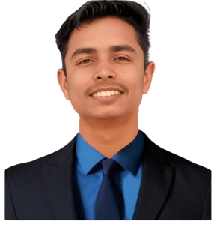

Certifications
- Python Programming 14 Dec – 31 Dec 2022
- Digital Marketing 1 May – 11 May 2023
- Hack-A-Thon 2024 16 Feb – 17 Feb 2024
- Foundation of Cloud IoT Edge ML Feb -- Apr 2024
- Mern Stack 14 oct – 25 Oct 2024
- Sensor-Network and Cloud IoT 1 Apr – 12 Apr 2025
- Python 3.4.3 1 Feb – 21 May 2025
- Data Analytics 1 July – 31 July 2025

Education
Bachelor of Technology in Computer Science May 2026
JB Institute of Technology, Shankarpur, Dehradun
Higher Secondary Education (12th Grade) May 2022
Shri Guru Ram Rai Public School, Muzaffarnagar
Secondary Education (10th Grade) May 2020
Celestial Angles Public High School, Barla, Muzaffarnagar

Technical Skills
- Computer Skills
- Internet Browsing
- Programming
- WordPress
- Tableau & Power BI

Experience
- Portfolio(https://portfolio-adhar-tyagi.vercel.app/)
- GYM Website

ADHAR TYAGI
Frontend Developer
+91 8171034485 adhartyagi1234@gmail.com Dehradun, India
Career Objective
Aspiring front-end developer with a strong foundation in HTML, CSS, and JavaScript, currently pursuing a B.Tech in Computer Science (2020–2026). Passionate about creating user-friendly web interfaces and bringing innovative ideas to life. Seeking opportunities to contribute technical expertise and creative skills to a dynamic development team. Also skilled in data analytics using Tableau and Power BI to transform complex data into meaningful visual insights

